OBSERVATION1:

Balance option is there in wireframe but in ledger page.

Ledger page:

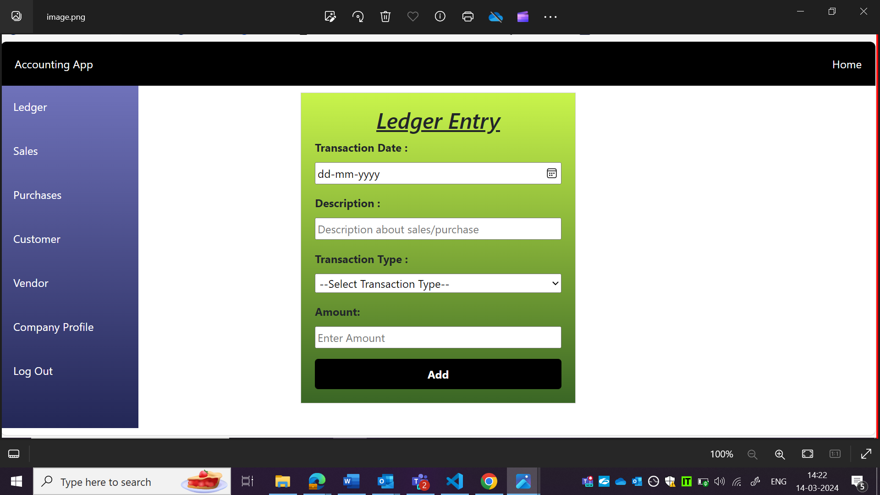

Wireframe:

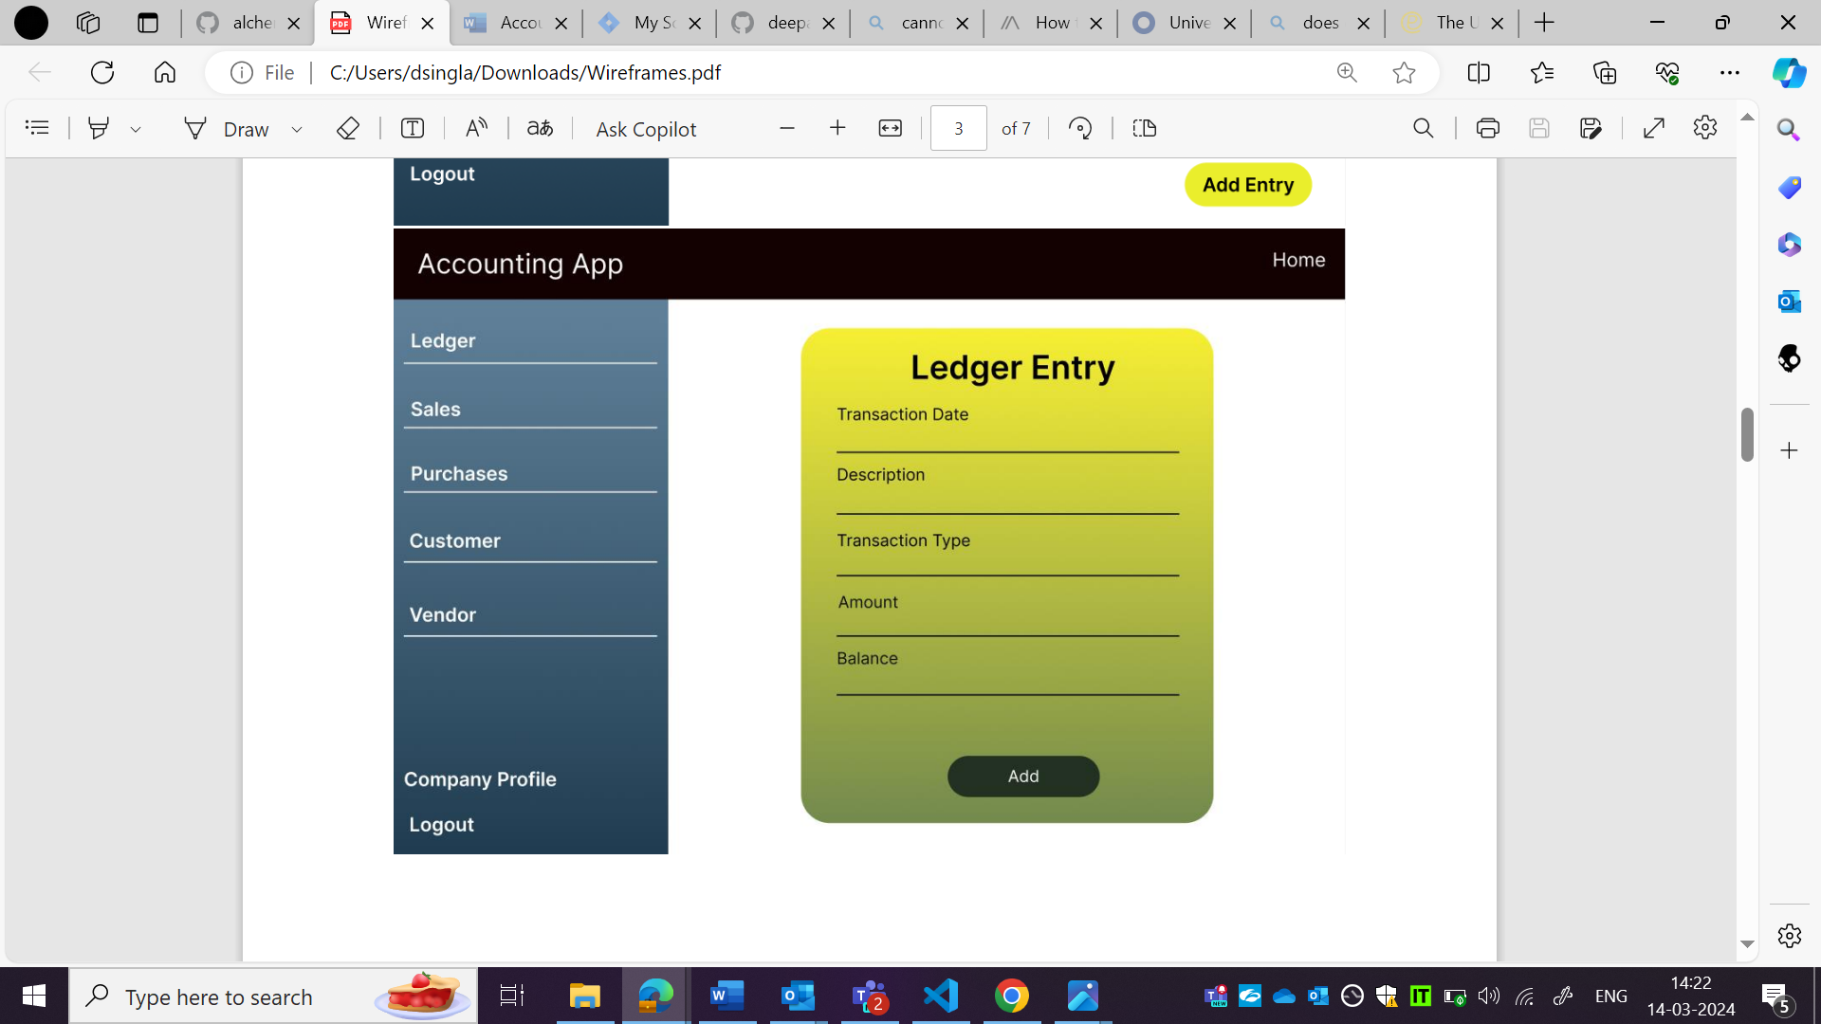

OBSERVATION2:

Add button is not as per wireframe.

Ledger page:



Wireframe:



OBSERVATION3:

Ledger entry text is not as per wireframe.

Ledger page:



Wireframe:



OBSERVATION4:

Side bar is not as per wireframe.

Ledger page:



Wireframe:



OBSERVATION5:

Colon are not there in wireframe but it is there in ledger page.

Ledger page:



Wireframe:



OBSERVATION6:

Ledger entry form border is not as per wireframe.

Ledger page:



Wireframe:

